EECS E6893 HW2

Jing Qian (jq2282)

**Question 1**

(1) Screenshots of the code

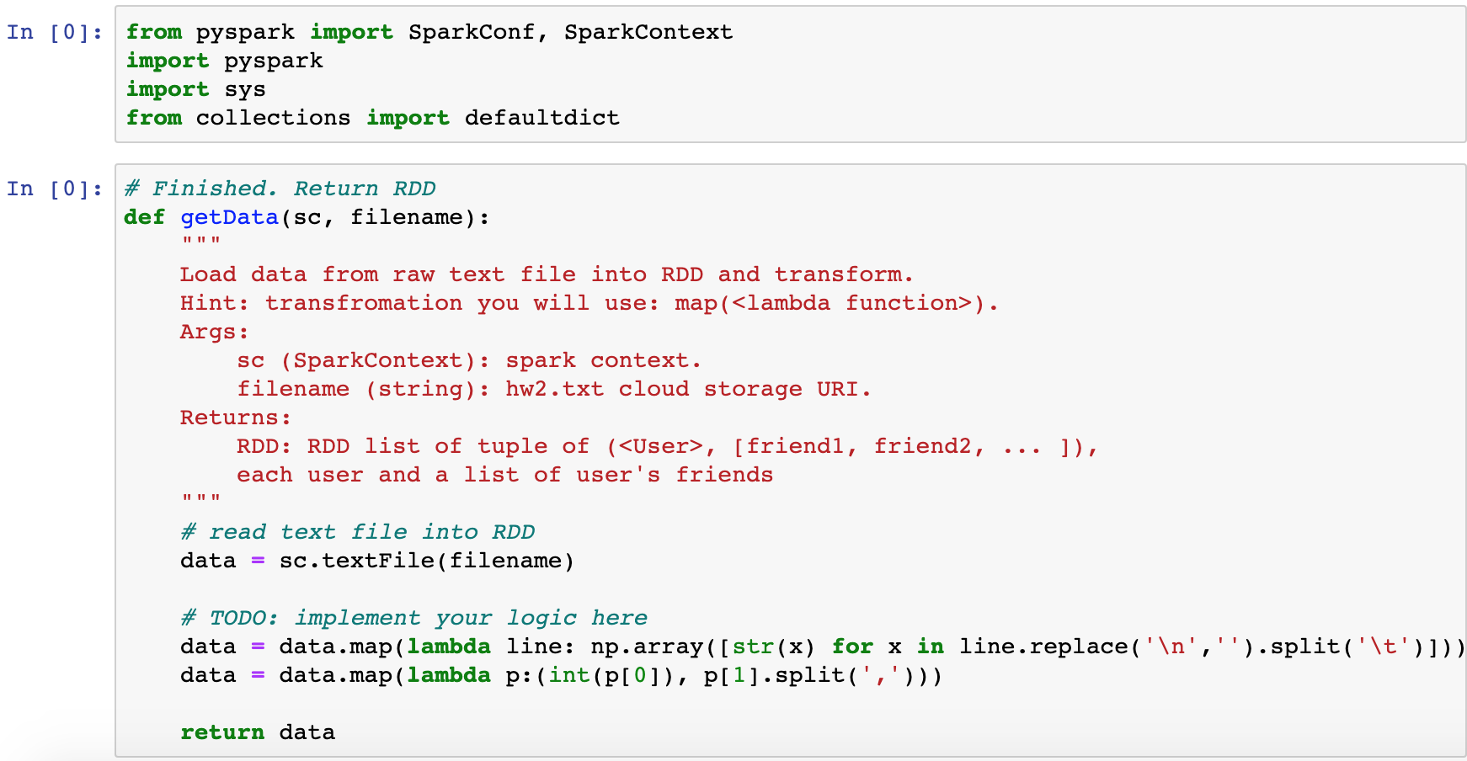

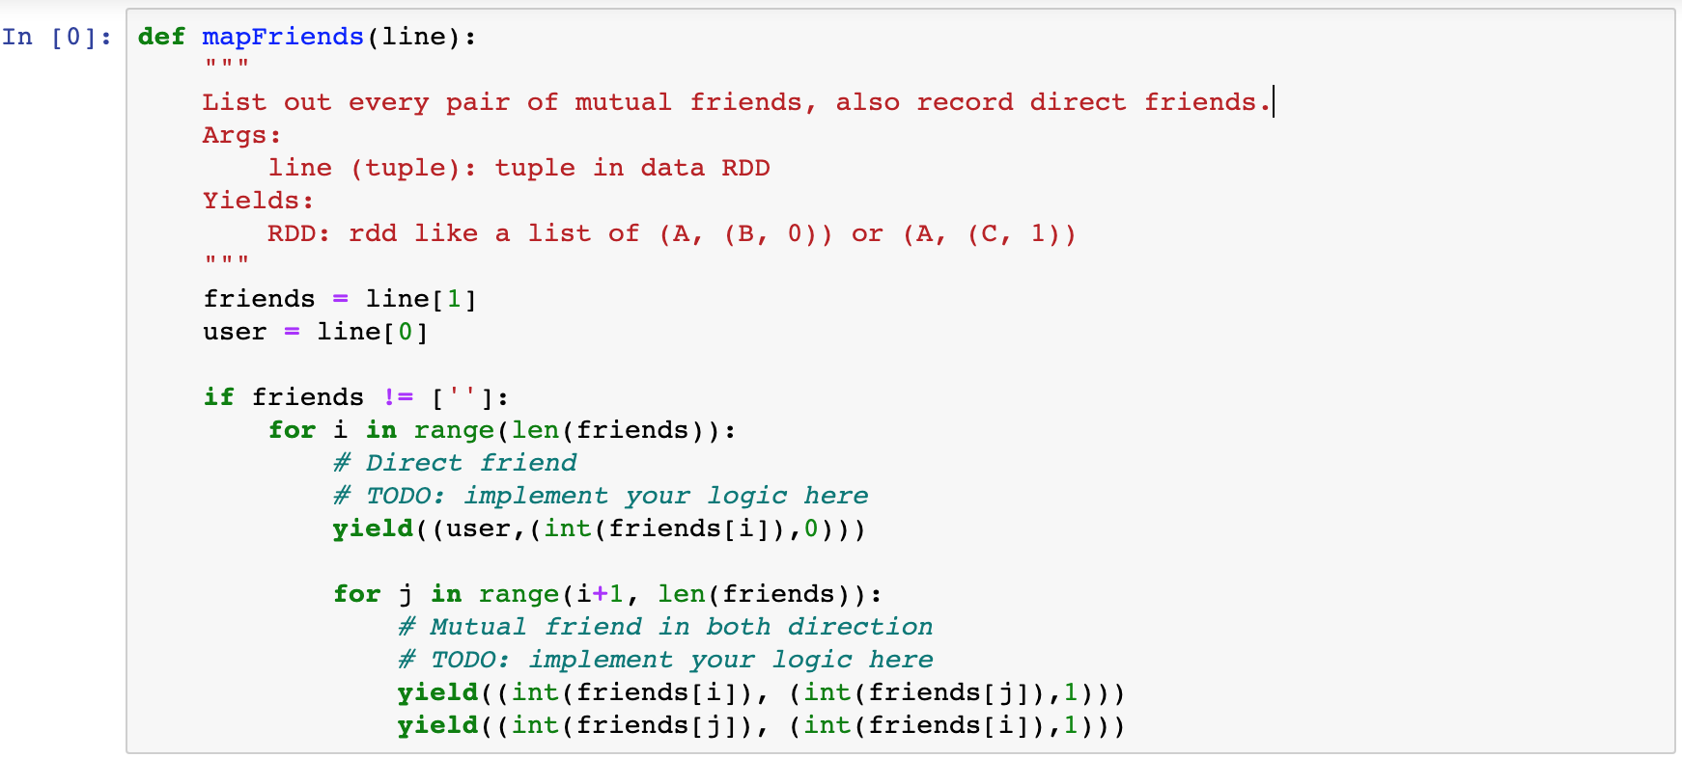

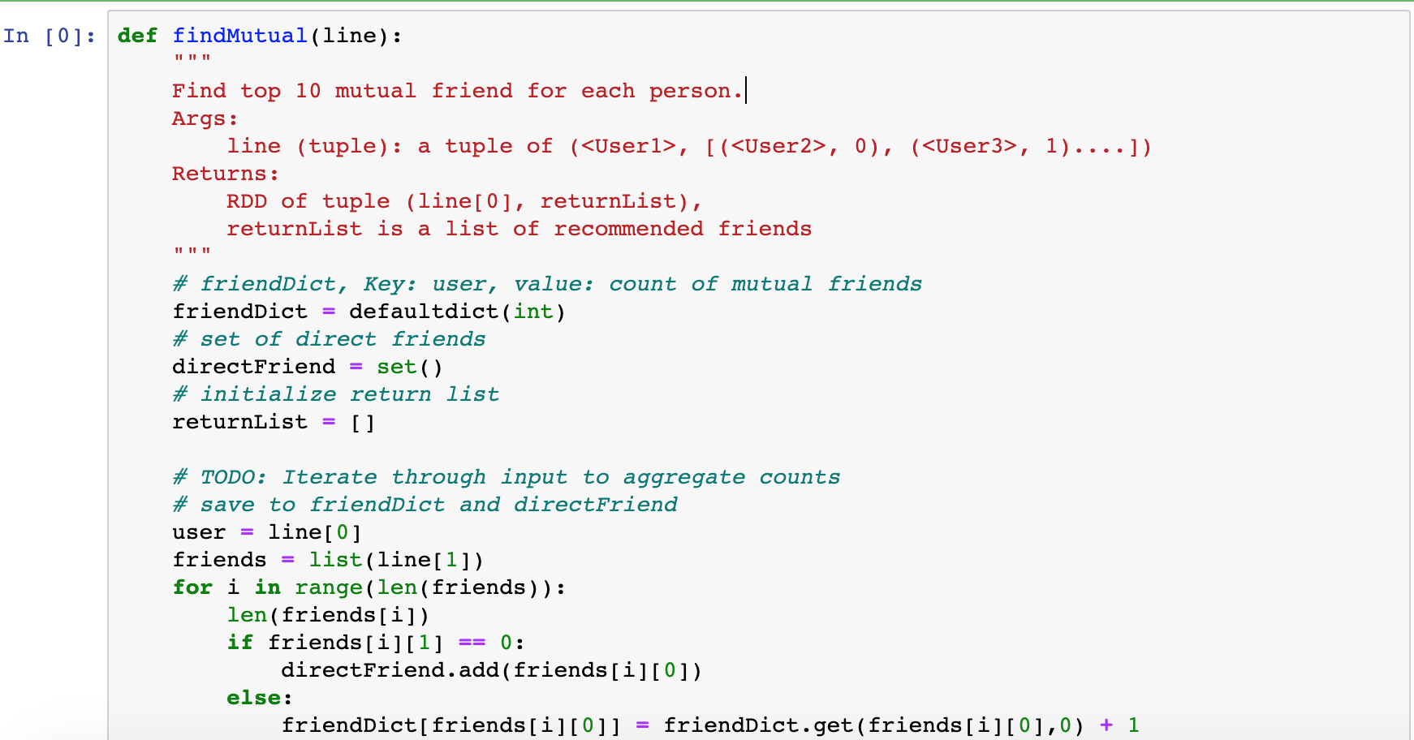

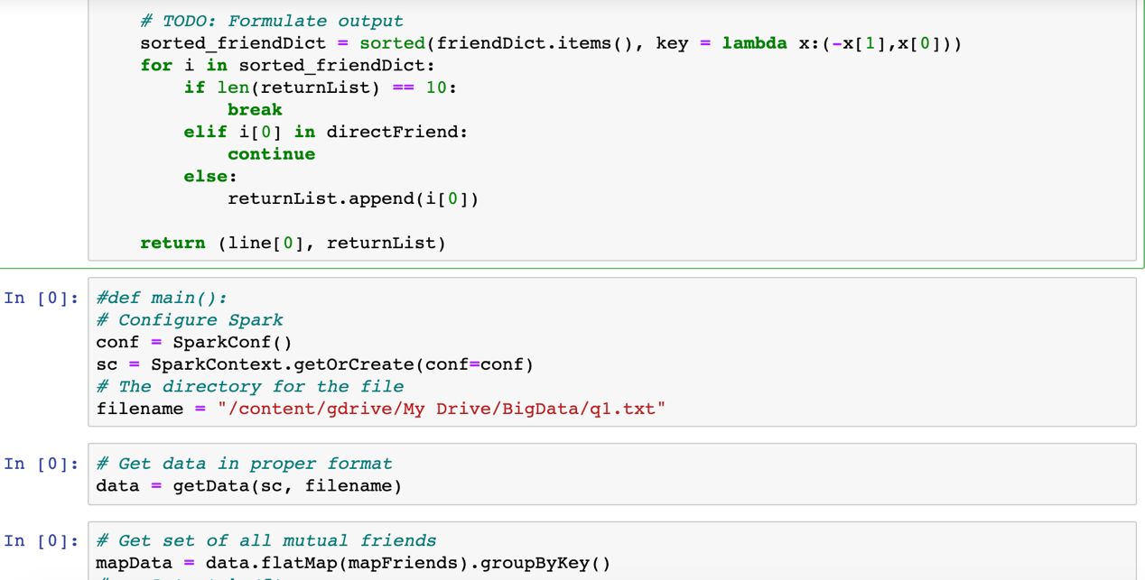

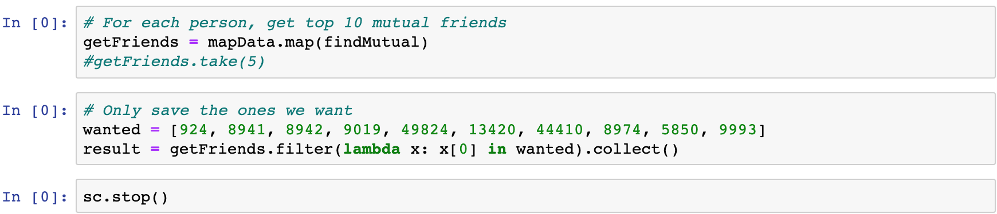

(2) Screenshots of the recommendation results.

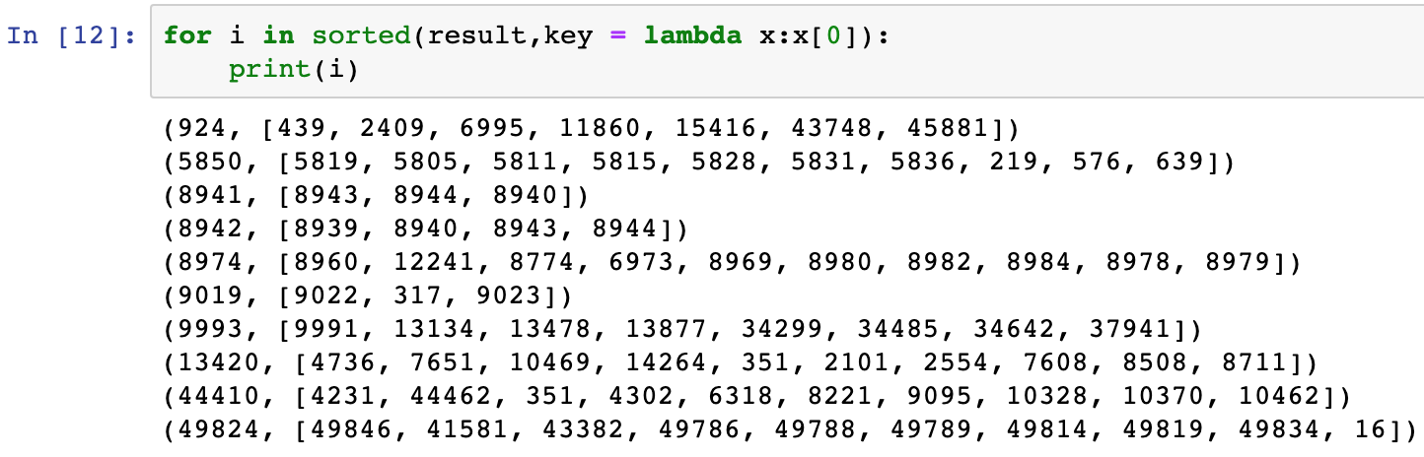

**Question 2 Graph Analysis**

(1) There are 917 clusters/connected components in total for this dataset.

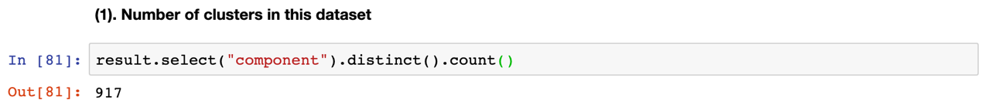

(2) There are 49045 users in the top 10 clusters.

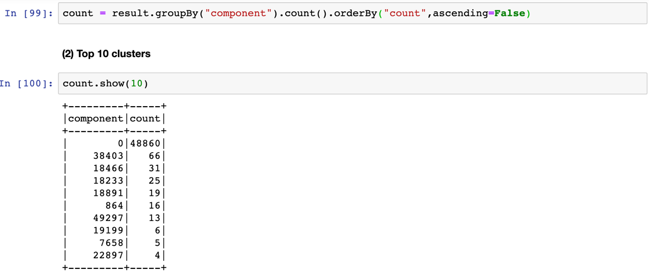

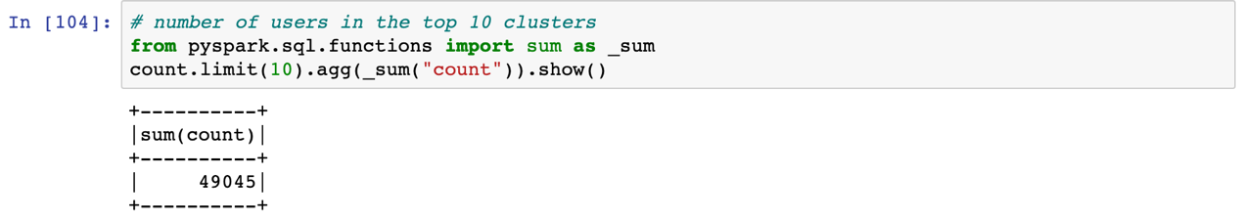

(3) The user ids for the cluster which has 25 users are: 18233 - 18257.

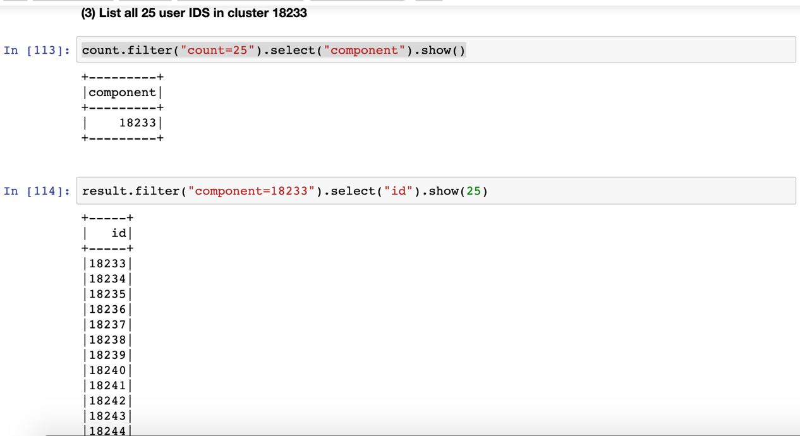

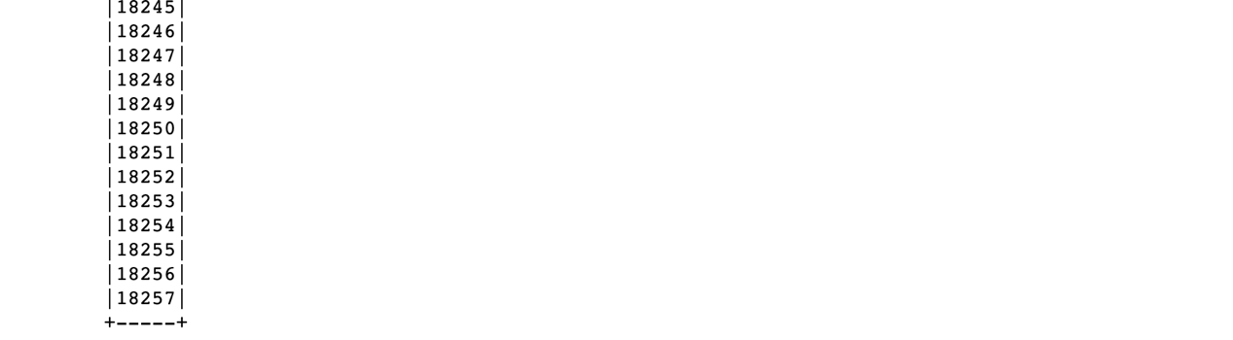

(4) The most important user is the one with User ID 10164.

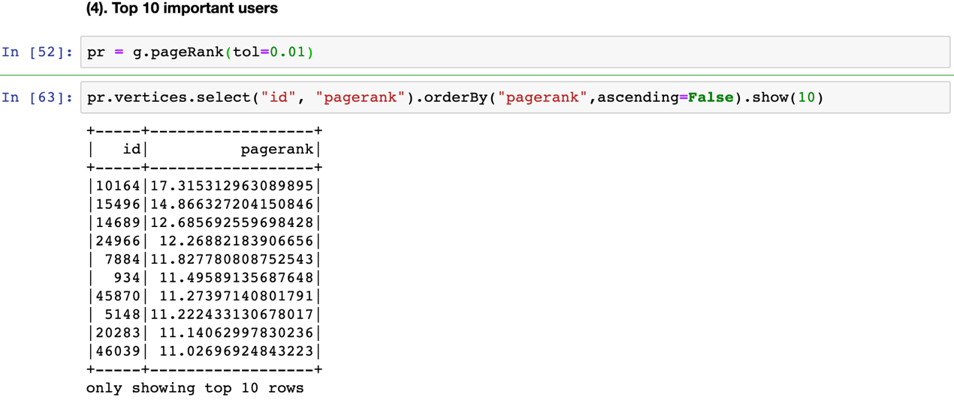

(5) Using different parameters setting for PageRank would lead to differences in the result. ???未完成

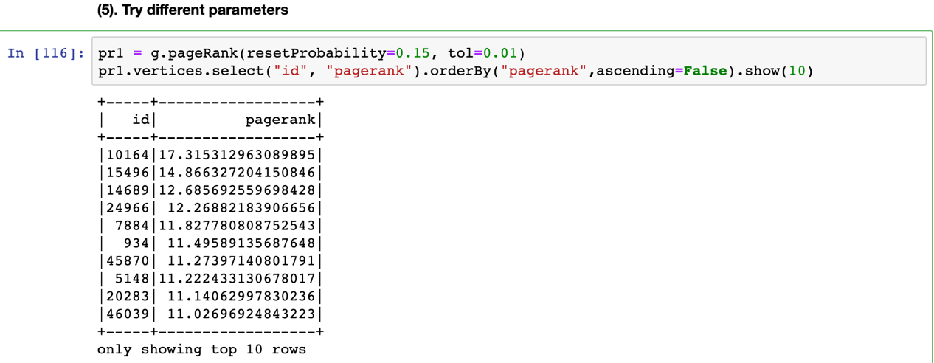

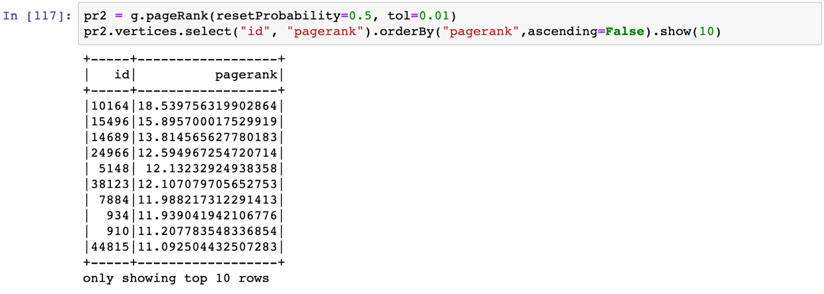

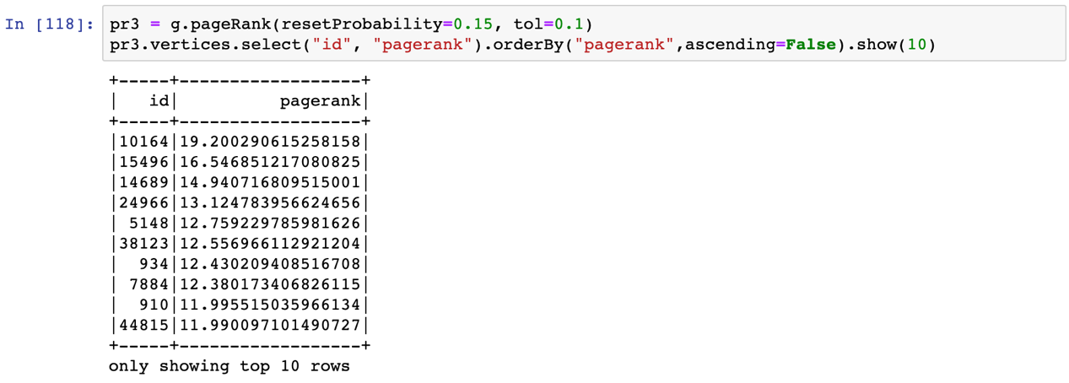

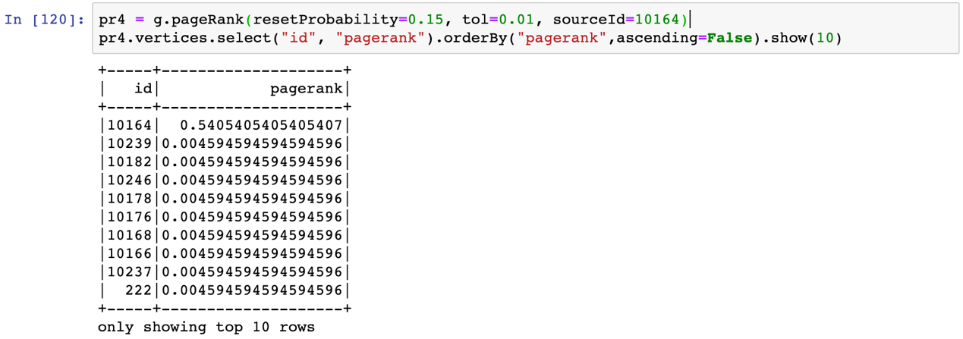

(6) ???未完成. 10164是最important的 也不是特别清楚，就是它在最大的群里，有着很多edges。

(7) PageRank Calculation

For this question, I used self-defined function to do the calculation and the result is as following along with the code.

